Test Case: tc001_SPX_Dev5_Crear_Requisicion_Spot_Tipo_Cobro_CC
Step 1 - Enter username and password and click to button Enter : Credentials Entered
Image file-name: QC_Testing-tc001_SPX_Dev5_Crear_Requisicion_Spot_Tipo_Cobro_CC-1789482662928

Step 2 - Select to UEN and Access to Spot Buy Requisitions : UEN Correctly selected and Correct access
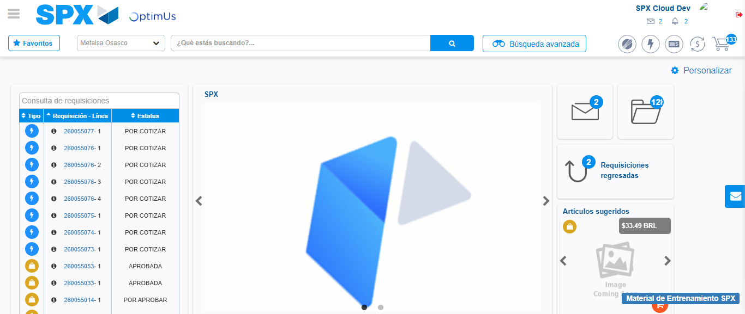Image file-name: QC_Testing-tc001_SPX_Dev5_Crear_Requisicion_Spot_Tipo_Cobro_CC-1789482686892

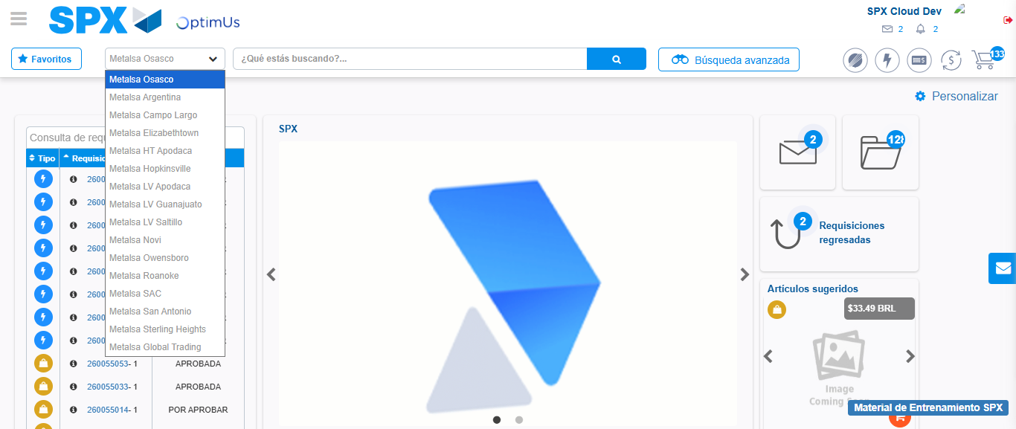Image file-name: QC_Testing-tc001_SPX_Dev5_Crear_Requisicion_Spot_Tipo_Cobro_CC-1789482687641

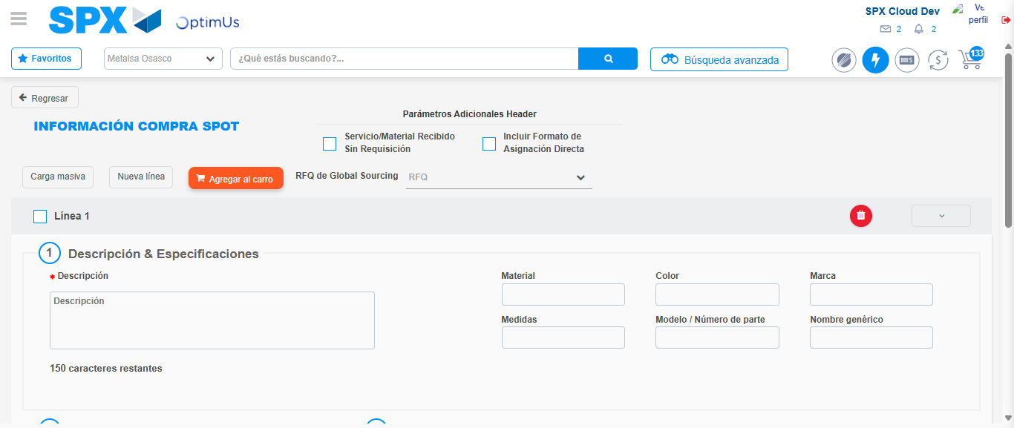Image file-name: QC_Testing-tc001_SPX_Dev5_Crear_Requisicion_Spot_Tipo_Cobro_CC-1789482692184

Step 3 - Data Capture Spot Buy Requisition : Data captured correctly
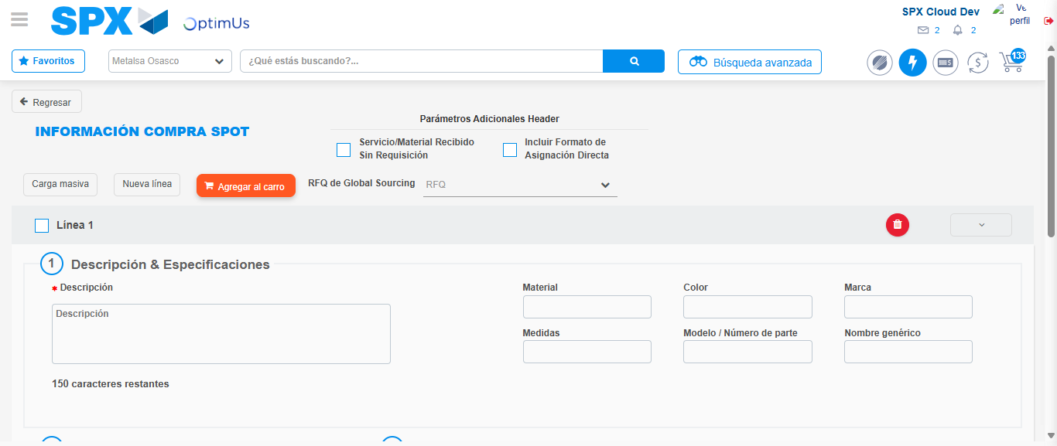Image file-name: QC_Testing-tc001_SPX_Dev5_Crear_Requisicion_Spot_Tipo_Cobro_CC-1789482692485

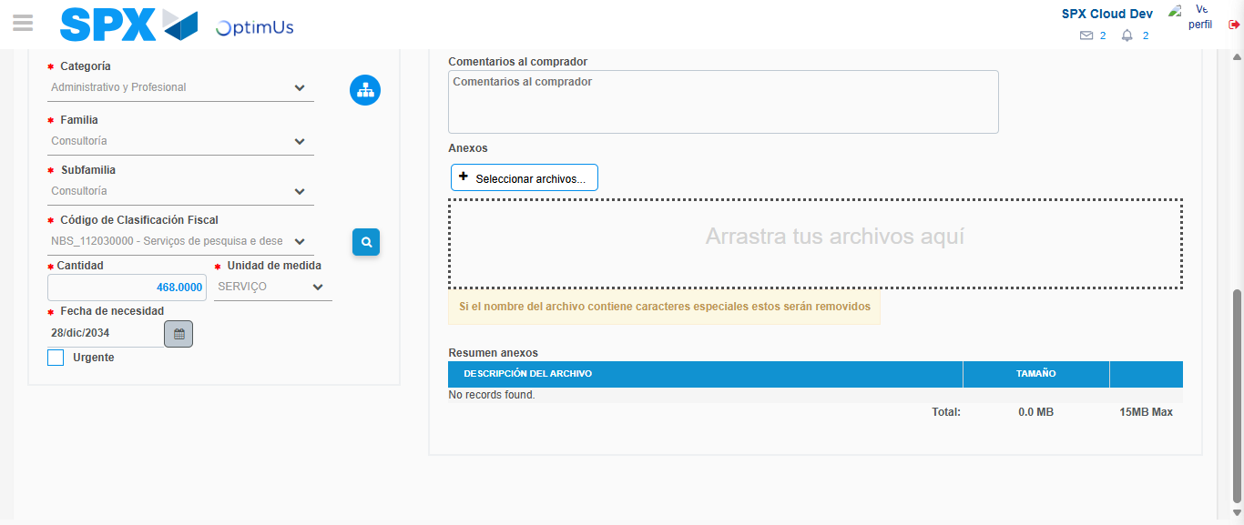Image file-name: QC_Testing-tc001_SPX_Dev5_Crear_Requisicion_Spot_Tipo_Cobro_CC-1789482710699

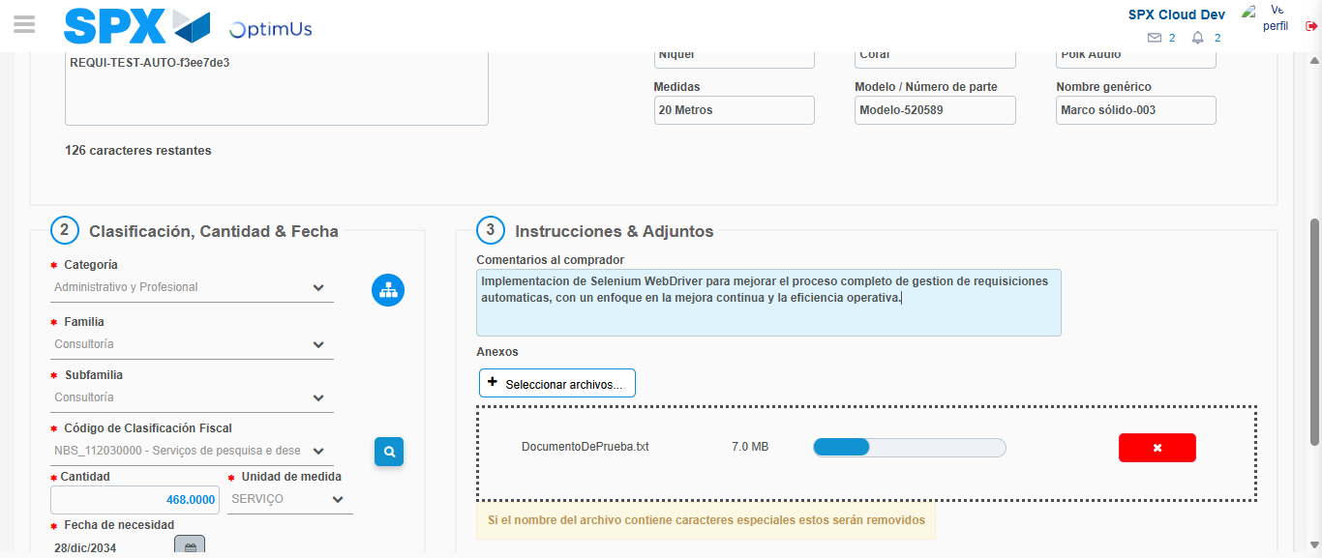Image file-name: QC_Testing-tc001_SPX_Dev5_Crear_Requisicion_Spot_Tipo_Cobro_CC-1789482711632

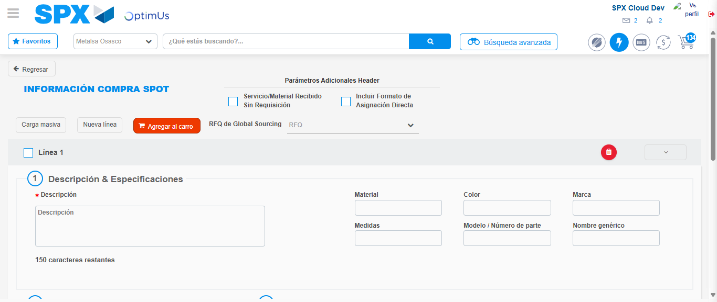Image file-name: QC_Testing-tc001_SPX_Dev5_Crear_Requisicion_Spot_Tipo_Cobro_CC-1789482717326

Step 7 - Return to Main Page SPX : Return to Main Page SPX
Image file-name: QC_Testing-tc001_SPX_Dev5_Crear_Requisicion_Spot_Tipo_Cobro_CC-1789482686892

Image file-name: QC_Testing-tc001_SPX_Dev5_Crear_Requisicion_Spot_Tipo_Cobro_CC-1789482687641

Image file-name: QC_Testing-tc001_SPX_Dev5_Crear_Requisicion_Spot_Tipo_Cobro_CC-1789482692184

Image file-name: QC_Testing-tc001_SPX_Dev5_Crear_Requisicion_Spot_Tipo_Cobro_CC-1789482719640

Image file-name: QC_Testing-tc001_SPX_Dev5_Crear_Requisicion_Spot_Tipo_Cobro_CC-1789482719914

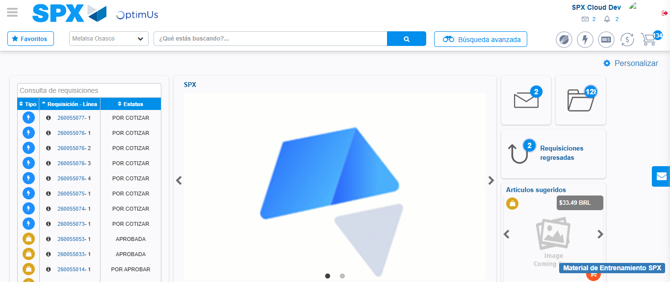Image file-name: QC_Testing-tc001_SPX_Dev5_Crear_Requisicion_Spot_Tipo_Cobro_CC-1789482741453

Step 8 - Log Out : Log Out SPX
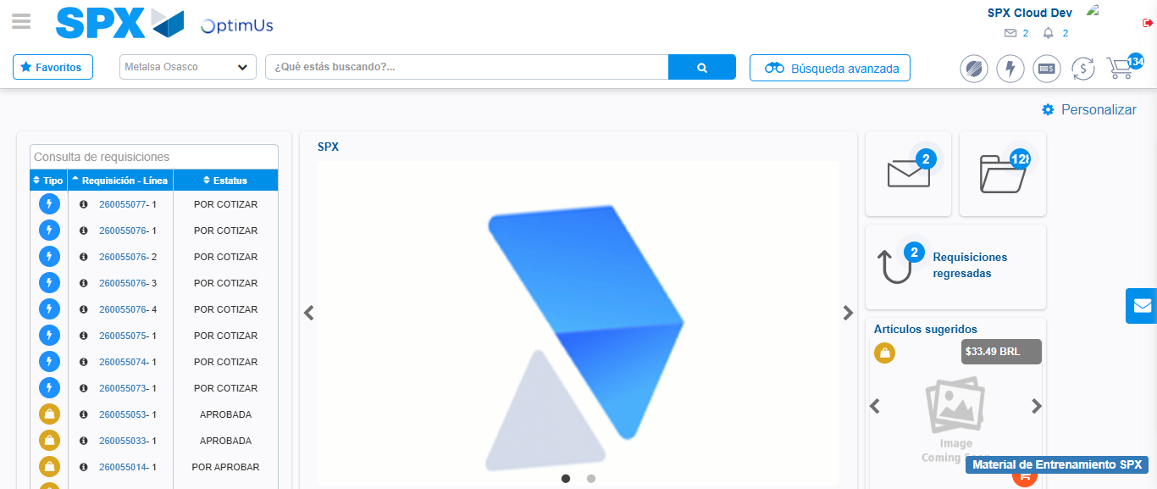Image file-name: QC_Testing-tc001_SPX_Dev5_Crear_Requisicion_Spot_Tipo_Cobro_CC-1789482741819

